**Meeting notes:** [**https://docs.google.com/document/d/1CewmCo5uz52QXsdqY8KxgHLv8RM1xWXkamRkMb-B4_o/edit?usp=sharing**](https://docs.google.com/document/d/1CewmCo5uz52QXsdqY8KxgHLv8RM1xWXkamRkMb-B4_o/edit?usp=sharing)

**Data set Description**

Include number of rows, topics, the process of how the data was collected etc.

Process followed for Youtube: Search for keywords (noted in italics), gather results from the first page and filter ones with >50 comments

*alcohol ban tamilnadu news*

<https://www.youtube.com/watch?v=fJ3OJp78xkM>

<https://www.youtube.com/watch?v=wJrCN8FExcA>

*Jallikattu ban Tamilnadu news*

<https://www.youtube.com/watch?v=kvfMr5-lmAw>

<https://www.youtube.com/watch?v=RWUdotGfZtA>

<https://www.youtube.com/watch?v=_ed0lSvsc50>

<https://www.youtube.com/watch?v=gA29_21sjvk>

**Coding scheme**

| Quality | High/ Med/ Low | * + Based on evidence   + Clarity   + Check for grammatical consistency   + Cogency, effectiveness, reasonableness   + Low - derogatory remarks   + High - has reasoning and evidence   + Med - the rest comes here, including links with no explanations |
| --- | --- | --- |
| For/Against/Undetermined  In relation to parent tweet | Agreement  1 or 0 | * + For - to the parent tweet, not the topic   + For if they agree with the course of action presented (E.g. Support for taking the covid vaccine, Supporting alcohol, Supporting jallikattu, Supporting NEET, Supporting free bus pass for women)   + Taking a ‘For’ stance   + Even consider if for stance is implicit |
| Disagreement  1 or 0 | * + Against - to the parent tweet, not the topic   + Against if they disagree and take the opposite point of view (E.G. Do not want to take the vaccine, Against alcohol, Against jallikattu, Against NEET, Against free bus pass for women)   + Taking an ‘Against’ stance   + Even consider if against stance is implicit   E.g. It’s a shame  பட்டாசு வெடிப்பதற்கு 2 மணி நேரம், குடிப்பதற்கு 10 மணி நேரம் |
| **Sub-categories :**  Hierarchy of argumentation | | |
|
| Level of statement | Argumentation with additional reasoning, evidence or detailed explanation  (1/0) | * + Provide a reasoning and evidence or detailed explanation of the context   + Contradicts and backs it up with reasoning   + Agrees and back it up with reasoning   + Check if there are words like : because, since, as, for the reason that, in view of the fact that -> which gives evidence; for Tamil words like : ஏனெனில், இருப்பதால், காரணத்தினால் (could be implicit as well)   + Analyze the evidence presented   + Evaluate the quality and credibility of the evidence   + Check for logical consistencies   + Check for links provided |
| Comment only  (no reasoning provided)  (1/0) | * + Provide their POV and own opinion   + Add some content on the topic (which may or may not be accurate) |
|  | Responding to tone  (1/0) | * + Responding to **tone without addressing the substance or content** of the argument |
|  | Discussing the writer’s characteristics  (1/0) | * Talking about the characteristics of the **writer or authority** **without addressing the substance** - could be attacks or praise |
|  | Remark  (Praise or derogatory)  (1/0) | * + Praise for a person without reasoning   + Name-calling   + Look for bad/offensive words   + Look for the intent of the argument   + Attack on person, rather than a response to the topic |
|  | Relevant or Irrelevant | * + Check if the topic keyword/synonym is there   + Look for context   + Evaluate the argument's connection to the topic   + Look for logical coherence   + Related to the parent tweet/content (the image/video/link/person who tweeted it)   + Sarcastic content which may not be obviously relevant can still be relevant **(Note down such examples)** |

Describe each category, and provide examples

How the scheme was derived, including references to past work - hierarchy of disagreement

Developed to study how people communicate their views and the language used for argumentation and disagreements, focus of the study is not on accuracy/ facts

**Coding process**

How many coders

How many rows were coded together, final reliability score

**Findings from the data set**

**Basic Info of Dataset**

* The dataset consists of 1350 tweets in total belonging to 5 different topics namely 'Jalikattu' 'Free bus commute for women. boon or bane' 'Covid vaccine - Boon or bane' 'Alcohol and Drugs' 'NEET: Boon or Bane'.
* It has 14 columns in total. The columns “SNO”, “Tweets”, “Date of Tweet”, “Parent Tweet”, “Topic” and “Language” are predefined and the coding is done for the rest of the columns namely “Quality”, “stance”, “Argumentation”, “comments”, “Responding to tone”, “Discussing the writer’s characteristics”, “Remark” and “Relevancy”.
* Therefore the basic shape of the dataset is (1350,14)
* Data types in the dataset are provided below

Sno column count null Dtype

0 sno 1350 non-null int64

1 Tweet 1350 non-null object

2 Date 1350 non-null datetime64[ns]

3 Topic 1350 non-null object

4 Parent_Tweet 1350 non-null object

5 Language 1350 non-null object

6 Quality 1350 non-null object

7 Stance 1350 non-null object

8 Argumentation 1350 non-null int64

9 Comment 1350 non-null int64

10 Responding_to_tone 1350 non-null int64

11 writer_characteristics 1350 non-null int64

12 Remark 1350 non-null int64

13 Relevancy 1350 non-null object

**Unique Values and Frequency**

* Number and percentage of tweets in each topic is given below

**column Number Percentage**

Covid vaccine - Boon or bane 382 28.3

Jalikattu 346 25.6

Alcohol and Drugs 286 21.2

Free bus commute for women. boon or bane 267 19.8

NEET: Boon or Bane 69 5.1

* Total number of unique Parent Tweet in the dataset : 41
* Total number of unique parent tweets in each topic is given below

**column Number of parent tweets**

Covid vaccine - Boon or bane 12

Jalikattu 8

Alcohol and Drugs 7

Free bus commute for women. boon or bane 9

NEET: Boon or Bane 5

* The unique values in each coded column of the dataset is provided below along with the total number of value_counts

1. **Language**

ENGLISH 623

CODE-MIXED 397

TAMIL 330

1. **Quality**

Med 849

Low 304

High 197

1. **Stance**

Against 626

Undetermined 437

For 287

1. **Argumentation**

0 1139

1 211

1. **Comment**

1 1047

0 303

1. **Responding_to_tone**

0 1112

1 238

1. **writer_characteristics**

0 990

1 360

1. **Remark**

0 1009

1 341

1. **Relevancy**

Relevant 1251

Irrelevant 99

* The percentage for the same is mentioned below

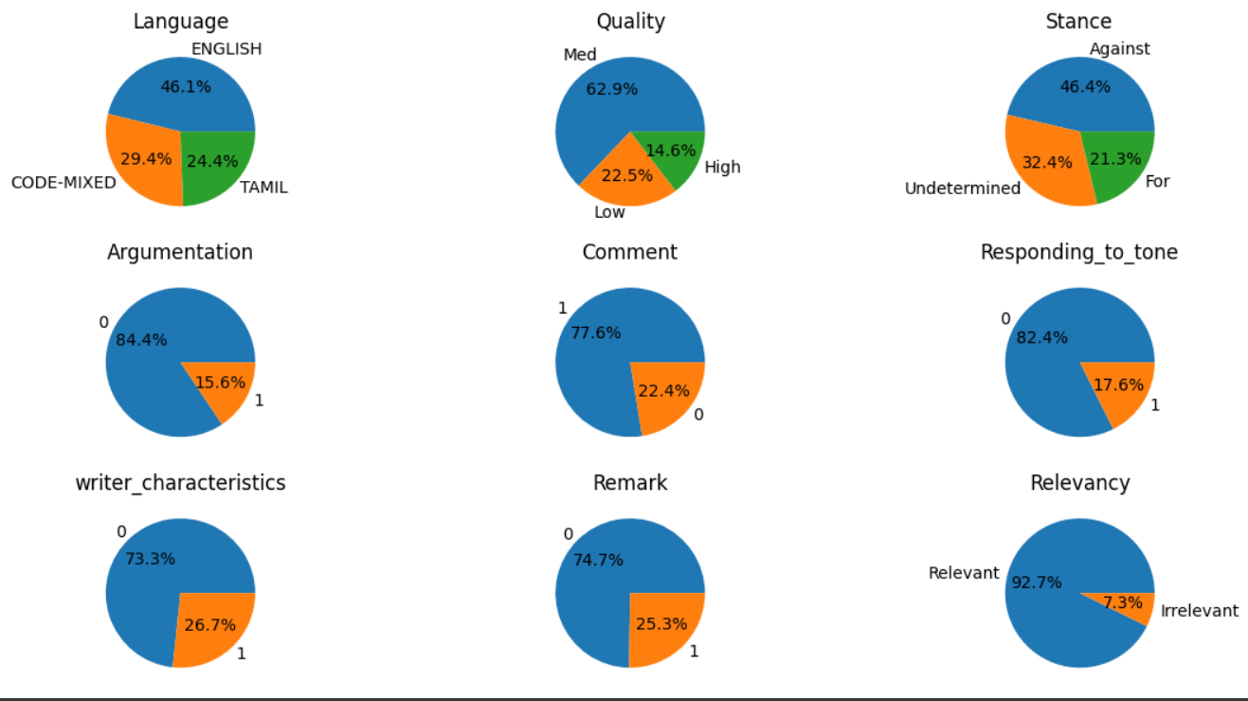

**Word Count**

* The word counts of all the tweets in the dataset was computed and the mean and the mode word count was found.

Mean word count of dataset = 14

Mode/ Mostly used word count = 4

The below box plot shows us the minimum and maximum word count along with several outliers present in the dataset

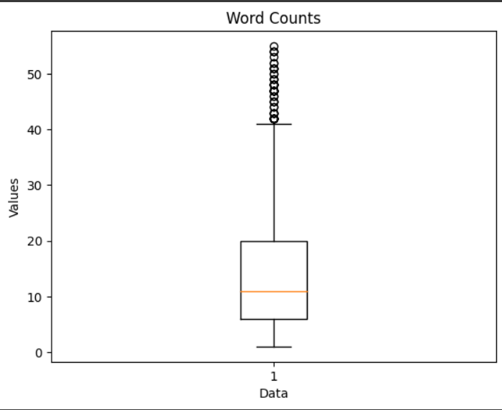

* There are certain tweets that use one, two or three words. These tweets are mostly remarks, which can either be a praise like “Nice”, “good job”, “well done“ or can also be derogatory comments. Certain tweets give a very short reason for the issue without any explanation. We see that about **12%** of the tweets are very short.

Number of Tweets with single word : 46

Number of Tweets with two words : 51

Number of Tweets with three words : 67

* We also have the average word count per topic

**Topic Average Word Count**

Jalikattu : 14

Free bus commute for women. boon or bane : 14

Covid vaccine - Boon or bane : 12

Alcohol and Drugs : 15

NEET: Boon or Bane : 11

* We also have the WC based on all other columns and classes. We can infer that people are able to put up more words while using a single language like English or Tamil when compared to code-mixed tweets. It is very obvious that the high quality comments are usually lengthy as tehy have reasoning and evidence for the tweets. It is surprising that the irrelevant tweets are as long as 12 words on an average which is almost similar to the relevant tweets.

**Language**

ENGLISH : 19

CODE-MIXED : 9

TAMIL : 11

**Quality**

Med : 12

High : 24

Low : 14

**Stance**

Undetermined : 11

Against : 16

For : 15

**Argumentation**

0 : 12

1 : 24

**Comment**

1 : 15

0 : 9

**Responding_to_tone**

0 : 14

1 : 13

**writer_characteristics**

0 : 13

1 : 16

**Relevancy**

Relevant : 14

Irrelevant : 12

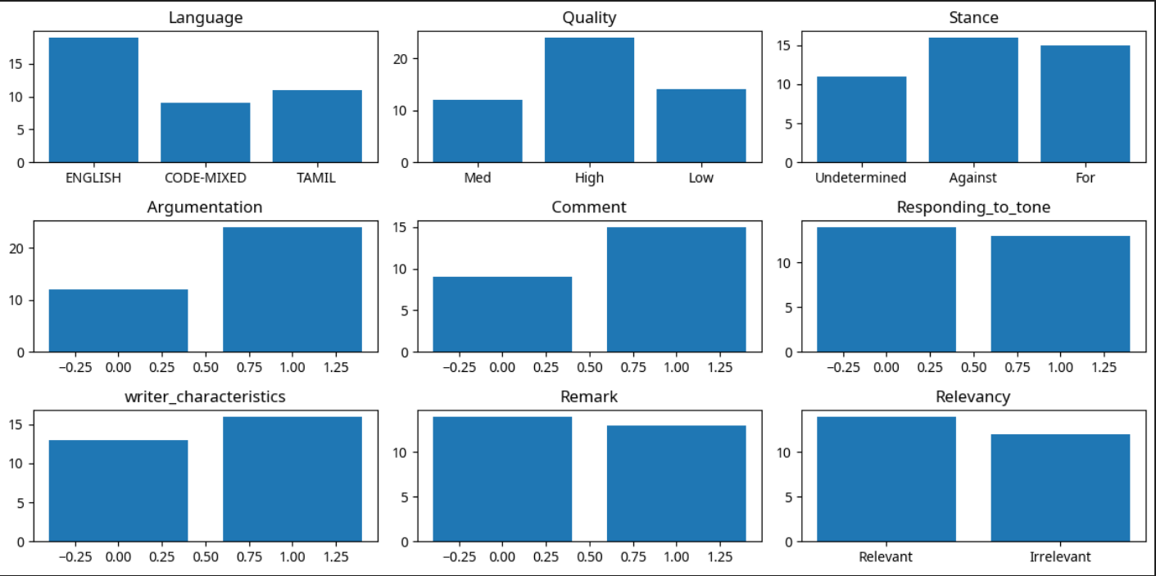

**Word Frequencies**

* Similar to the word count, the frequency of the words also help us in telling about the words that are used a lot in the tweets. However, we remove the puctuators along with the stopwords that are used in a language as they do not directly contribute to the context of the tweets.
* The stopwords are removed from both English and Tamil languages, however not from the code-mixed tweets. The most used words along with their frequencies are given below.

**English**: [('tn', 67), ('dont', 61), ('people', 61), ('like', 47), ('data', 45), ('sir', 40), ('govt', 38), ('state', 37), ('know', 31), ('get', 30), ('jallikattu', 28), ('population', 28), ('tasmac', 26), ('good', 25), ('tamil', 25), ('tamilnadu', 24), ('vaccine', 24), ('one', 23), ('free', 23), ('government', 22)]

**Code-Mixed**: [('da', 30), ('oru', 22), ('la', 18), ('sir', 18), ('enna', 16), ('nee', 16), ('nu', 15), ('ku', 14), ('tn', 14), ('dmk', 12), ('tweet', 10), ('unaku', 10), ('ena', 10), ('review', 9), ('தன', 9), ('poi', 9), ('ah', 9), ('user_74', 9), ('ஒர', 9), ('dai', 8)]

**Tamil**: [('ஒரு', 25), ('போய்', 15), ('திமுக', 15), ('உங்க', 14), ('சீனா', 14), ('அரசு', 12), ('கட்சி', 12), ('உனக்கு', 12), ('நீங்கள்', 11), ('மக்கள்', 11), ('நாயே', 11), ('இல்லை', 11), ('பெண்களுக்கு', 10), ('பேருந்து', 10), ('உங்களுக்கு', 10), ('உண்டியல்', 10), ('நீங்க', 9), ('இல்லையா', 9), ('மாரி', 9), ('கோடி', 9)]

A sample of the plot is given below.

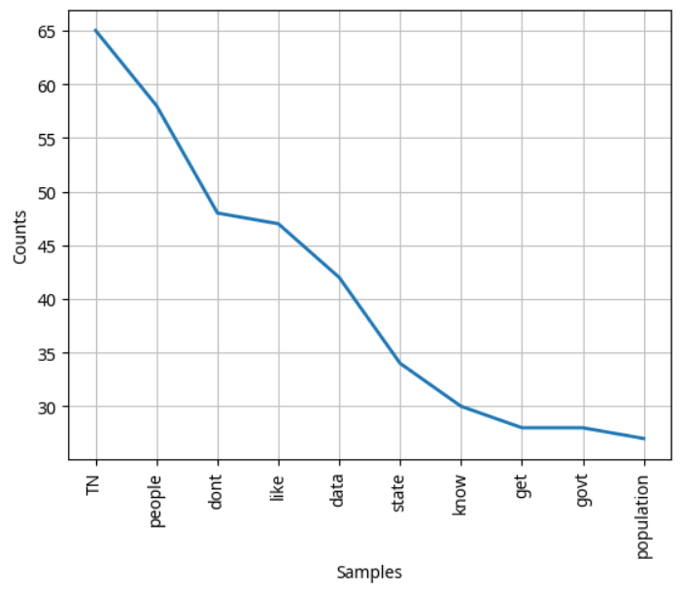

* To have a better visualization of the word frequencies, we can generate a word cloud.

**English**

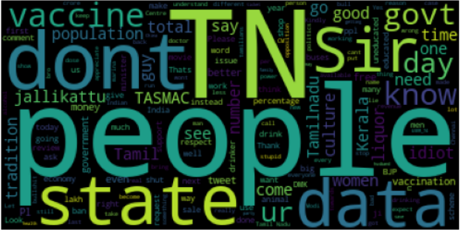

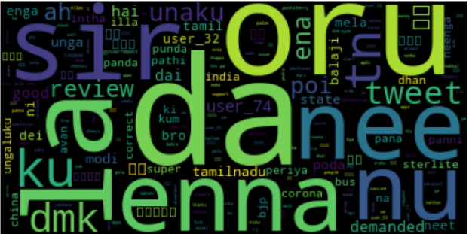

**Collocations and Associations**

* They tell us about the words that frequently occur together. We will find the collocations based on bigrams.

**English**

[('aagum', 'appo'), ('aariya', 'brahmin'), ('abandon', 'pplfor'), ('abusive', 'language'), ('ac', 'room'), ('accidents', 'suicides'), ('actual', 'illegal'), ('addict', 'agiruvanga'), ('adhere', 'prescribed'), ('admistration', 'karur')]

**Tamil**

[('ஃபேன்சி', 'ஸ்டோர்ஸ்'), ('அக்கவுண்ட்', 'போடு'), ('அக்கவுண்ட்ல', 'ஏறும்'), ('அக்கவுன்டல', 'போடுறேனு'), ('அங்கீகரிக்க', 'கல்வியை'), ('அச்சுறுத்தும்', 'நாஜி'), ('அடமானம்', 'வச்ச'), ('அடிப்பார்கள்', 'செய்வீர்களா')]

* Similarly, we have also found the word associations in the text.

**English**

[('Tamil', 'Nadu'), ('Arunachal', 'Pradesh'), ('without', 'knowing'), ('white', 'board'), ('free', 'bus'), ('stop', 'eating'), ('stop', 'reviewing'), ('Jesse', 'Jackson'), ('gon', 'na'), ('non', 'veg'), ('tail', 'end'), ('vote', 'bank'), ('central', 'government'), ('social', 'media'), ('state', 'govt')]

**Tamil**

[('கேள்வி', 'கேட்க'), ('நடவடிக்கை', 'எடுக்க'), ('சிலைக்கு', 'கோடி'), ('அ', 'ஒழிக்குறோம்'), ('அன்புமணி', 'ராமதாஸ்'), ('உருட்டிட்டு', 'இருந்தாங்களா'), ('ஏமாத்துனது', 'கவர்மெண்ட்')]

* Even though the above list gives us an idea on the association, it is difficult to find the keywords that we specifically need to understand the context of the words. Therefore, we use a filter on the bigrams found to specifically find the associations with the topic of the tweets.

**English**

[('anything', 'jallikattu'), ('jallikattu', 'protests'), ('abt', 'jallikattu'), ('commenting', 'jallikattu'), ('fyi', 'jallikattu'), ('hang', 'jallikattu'), ('jallikattu', 'calls'), ('jallikattu', 'hero'), ('jallikattu', 'jallikattuprotest'), ('jallikattu', 'ordinance')]

[('alcohol', 'consumption'), ('consuming', 'alcohol'), ('influence', 'alcohol'), ('alcohol', 'alternative'), ('alcohol', 'average'), ('alcohol', 'id'), ('alcohol', 'proper'), ('amount', 'alcohol'), ('banning', 'alcohol'), ('keralas', 'alcohol')]

[('cancel', 'neet'), ('neet', 'thirttu'), ('neet', 'exemption'), ('secret', 'neet'), ('talk', 'neet'), ('modi', 'neet'), ('neet', 'ban'), ('neet', 'tn')]

[('covid', 'warrior'), ('covid', 'pandemic'), ('supply', 'covid'), ('true', 'covid'), ('days', 'covid'), ('covid', 'vaccine')]

[('free', 'bus'), ('bus', 'pass'), ('bus', 'ticket'), ('levied', 'bus'), ('travelling', 'bus'), ('bus', 'daily'), ('bus', 'eh'), ('bus', 'fare'), ('bus', 'travel'), ('though', 'bus')]

**Tamil**

[('ஜல்லிக்கட்டு', 'போராட்டத்தின்'), ('பாருங்க', 'ஜல்லிக்கட்டு')]

[('மது', 'அருந்தும்'), ('ஓகோ', 'மது'), ('காட்டுங்கள்', 'மது'), ('பொருட்கள்', 'மது'), ('மது', 'கடைகளை'), ('மது', 'கடைக்கு'), ('மது', 'குடிப்பதில்'), ('மது', 'பிரியர்கள்'), ('வடமாநில', 'மது'), ('வேதனையில்', 'மது')]

[('நீட்', 'அ'), ('நீட்', 'விலக்கு'), ('இல்லாம', 'நீட்'), ('அடிபணியாமல்', 'நீட்'), ('அய்யா', 'நீட்'), ('காலைல', 'நீட்'), ('நீட்', 'க்கு'), ('நீட்', 'தேர்வு'), ('அதிமுக', 'நீட்')]

[('கேரளம்', 'கொரோனா'), ('கொரோனா', 'உருவாக்கியதுக்கும்'), ('கொரோனா', 'சாதனையையும்'), ('கொரோனா', 'தொற்றால்'), ('கொரோனா', 'பரவலை'), ('கொரோனா', 'பாதிப்பு'), ('த்தூத்தேரி', 'கொரோனா'), ('போவியா', 'கொரோனா'), ('மொத்த', 'கொரோனா'), ('கேரளா', 'கொரோனா')]

[('பஸ்', 'இதுவே'), ('பஸ்', 'பாஸ்'), ('பஸ்', 'போகுதுனு'), ('எத்தனை', 'பஸ்'), ('சாதாரண', 'பஸ்'), ('பேருந்து', 'பஸ்')]

**REGEX**

* We use regex to find the number of times the words of interest are used in the tweets.

Jallikattu : 51

NEET : 19

Covid or Vaccine: 80

Bus or Pass : 58

Alcohol or Tasmac or Liquor : 87

* We also find the number of times a link/ url is attached with the tweet and the number of time a user is tagged in the tweets.

Number of times a URL is provided as an evidence/ support : 15

Number of tags : 205

**Character Level Counts**

* Similar to word counts in each tweets, it is also important to find the number of characters in the tweets. The below histogram shows an overall picture of the number of characters in a tweet.

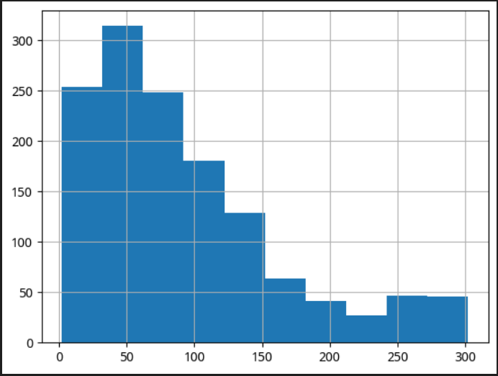

**Character counts**

Minimum : 2

Maximum : 302

Average : 91.94

Highest frequency (Mode) : 28

**STOPWORDS**

* The frequently used top stopwords are printed below

**English**

[('to', 333), ('the', 327), ('is', 247), ('of', 215), ('and', 196), ('you', 172), ('in', 163), ('a', 147), ('for', 137), ('this', 136), ('not', 118), ('are', 114), ('it', 98), ('u', 95), ('we', 76), ('be', 75), ('on', 70), ('will', 67), ('what', 65), ('with', 61)]

**Tamil**

[('தான்', 39), ('இந்த', 29), ('நீ', 23), ('என்ன', 21), ('என்று', 17), ('உன்', 15), ('இது', 13), ('எல்லாம்', 13), ('கொண்டு', 12), ('வேண்டும்', 10), ('உள்ள', 9), ('ஏன்', 8), ('மீது', 8), ('இருந்து', 8), ('பல', 7), ('இதை', 6), ('விட', 6), ('அந்த', 6), ('அதை', 5), ('இன்னும்', 5)]

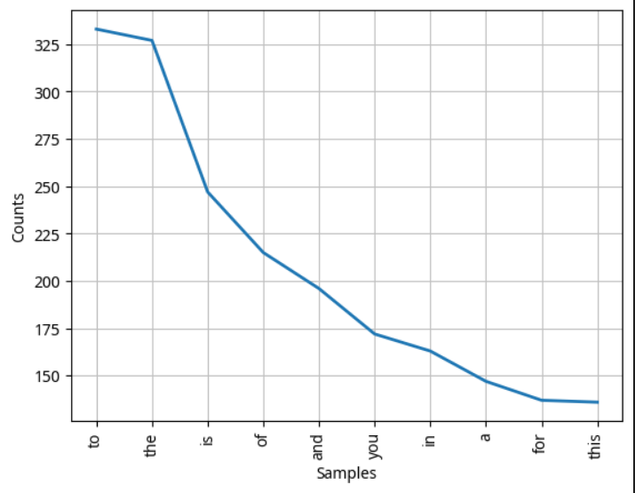

**Timeline of the tweets**

* The number of tweets in the dataset at different points in the timeline is computed and plotted. We have a large numer of tweets between 2021 and 2022 that was regarding the covid vaccination. This is followed by the tweets in 2023 and 2017 for NEET and Jallikattu respectively. The tweets in 2018 are for the sterlite issues.

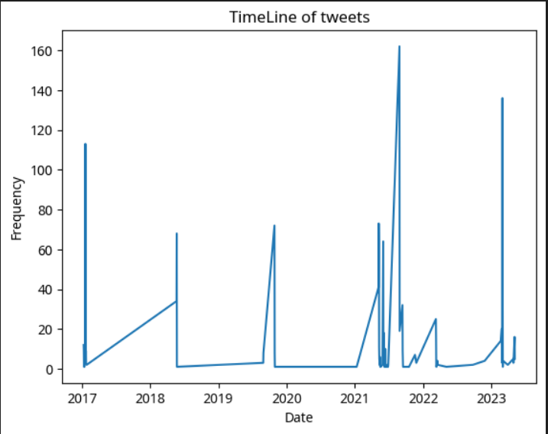

**EDA on Youtube Dataset**

# **Predictive Modelling**

## Predicting Quality

### BERT-multilingual-cased

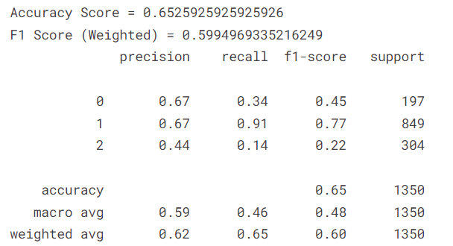

## Predicting Argument or Not

### BERT-multilingual-cased

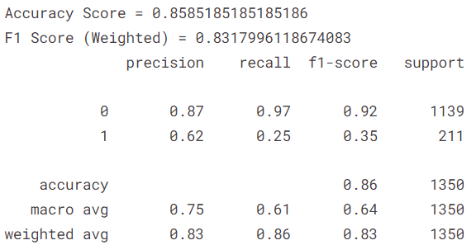

**Fine Tuning Results - BERT Multilingual Cased**

**Learning Rate**

| 0.1 | Accuracy Score = 0.6777777777777778  F1 Score (Weighted) = 0.666446075382849 |
| --- | --- |
| 0.01 | Accuracy Score = 0.6496296296296297  F1 Score (Weighted) = 0.6122972596323805 |
| 0.001 | Accuracy Score = 0.6229629629629629  F1 Score (Weighted) = 0.49188467617140985 |
| 0.0001 | Accuracy Score = 0.6303703703703704  F1 Score (Weighted) = 0.49054048561999536 |
| 0.00001 | Accuracy Score = 0.6229629629629629  F1 Score (Weighted) = 0.5364334171976093 |

**Optimizer**

| Adam | Accuracy Score = 0.6607407407407407  F1 Score (Weighted) = 0.6504619181751821 |
| --- | --- |
| AdamW | Accuracy Score = 0.6777777777777778  F1 Score (Weighted) = 0.666446075382849 |
| ASGD | Accuracy Score = 0.6229629629629629  F1 Score (Weighted) = 0.49318773680652805 |
| SGD | Accuracy Score = 0.6237037037037036  F1 Score (Weighted) = 0.48962780997024463 |
| NAdam | Accuracy Score = 0.6703703703703704  F1 Score (Weighted) = 0.6448418639485095 |
| RAdam | Accuracy Score = 0.6733333333333333  F1 Score (Weighted) = 0.6592357221375794 |

**Batch Size**

| 8 | Accuracy Score = 0.6725925925925926  F1 Score (Weighted) = 0.6637164294061837 |
| --- | --- |
| 16 | Accuracy Score = 0.6214814814814815  F1 Score (Weighted) = 0.6288607997397804 |
| 32 | Accuracy Score = 0.6777777777777778  F1 Score (Weighted) = 0.666446075382849 |
| 64 | Accuracy Score = 0.6325925925925926  F1 Score (Weighted) = 0.632002636206262 |

**Finalized hyperparameters**

**Batch size:** 32

**Learning Rate:** 0.1

**Epochs:** 10, 10 and 30 (XLM-Roberta, XLM-MLM-100-1280, Bert)

**Optimizer:** AdamW

**Loss function:** BCEwithlogitsloss

**Total Number of Models - (**no of datasets) x (no of attributes) x (number of models)

**Datasets** - 2 (Twitter and Youtube)

**Models** -3 (Bert, XLM-Roberta, XLM-MLM-100-1280)

**Attributes** - 9 (Quality, Stance wrt topic, Stance wrt content, Argument, Comment, Responding to tone, Writer characteristics, Remark, Relevancy)

No of models = 2 x 3 x 9 = 54

**Testing Results**

**BERT - MULTILINGUAL - CASED**

| **Quality**  Accuracy = 0.6769313884386818  F1 Score (Weighted) = 0.6745961682381202  precision recall f1-score support  0 0.74 0.53 0.62 394  1 0.66 0.73 0.70 849  2 0.67 0.70 0.68 608  accuracy 0.68 1851  macro avg 0.69 0.65 0.66 1851  weighted avg 0.68 0.68 0.67 1851 | **Remark**  Accuracy Score = 0.7397989355411  F1 Score (Weighted) = 0.7416362142538074  precision recall f1-score support  0 0.81 0.74 0.77 1009  1 0.66 0.74 0.70 682  accuracy 0.74 1691  macro avg 0.73 0.74 0.73 1691  weighted avg 0.75 0.74 0.74 1691 |
| --- | --- |
| **Stance wrt topic** | **Stance wrt content** |
| **Argument**  Accuracy Score = 0.8238308776425368  F1 Score (Weighted) = 0.8223878766133527  precision recall f1-score support  0 0.87 0.89 0.88 1139  1 0.68 0.65 0.67 422  accuracy 0.82 1561  macro avg 0.78 0.77 0.77 1561  weighted avg 0.82 0.82 0.82 1561 | **Comment**  Accuracy Score = 0.7652752571082879  F1 Score (Weighted) = 0.767929281563276  precision recall f1-score support  0 0.66 0.75 0.70 606  1 0.84 0.78 0.81 1047  accuracy 0.77 1653  macro avg 0.75 0.76 0.75 1653  weighted avg 0.77 0.77 0.77 1653 |
| **Responding to tone**  Accuracy Score = 0.7739294710327456  F1 Score (Weighted) = 0.7712084049916478  precision recall f1-score support  0 0.83 0.86 0.84 1112  1 0.63 0.58 0.61 476  accuracy 0.77 1588  macro avg 0.73 0.72 0.72 1588  weighted avg 0.77 0.77 0.77 1588 | **Writer characteristics**  Accuracy Score = 0.7508771929824561  F1 Score (Weighted) = 0.7518870365870765  precision recall f1-score support  0 0.80 0.76 0.78 990  1 0.69 0.74 0.71 720  accuracy 0.75 1710  macro avg 0.75 0.75 0.75 1710  weighted avg 0.75 0.75 0.75 1710 |
| **Relevancy**  Accuracy Score = 0.9054520358868184  F1 Score (Weighted) = 0.8988440436430472  precision recall f1-score support  0 0.93 0.97 0.95 1251  1 0.71 0.52 0.60 198  accuracy 0.91 1449  macro avg 0.82 0.74 0.77 1449  weighted avg 0.90 0.91 0.90 1449 |  |

**XLM-Roberta-Base**

| **Quality**  Accuracy Score = 0.6645085344320188  F1 Score (Weighted) = 0.6643408367410025  precision recall f1-score support  0 0.60 0.56 0.58 394  1 0.72 0.69 0.70 849  2 0.63 0.70 0.66 456  accuracy 0.66 1699  macro avg 0.65 0.65 0.65 1699  weighted avg 0.67 0.66 0.66 1699 | **Remark**  Accuracy Score = 0.726788882318155  F1 Score (Weighted) = 0.7276672916040514  precision recall f1-score support  0 0.78 0.76 0.77 1009  1 0.65 0.68 0.67 682  accuracy 0.73 1691  macro avg 0.72 0.72 0.72 1691  weighted avg 0.73 0.73 0.73 1691 |
| --- | --- |
| **Stance wrt topic** | **Stance wrt content** |
| **Argument**  Accuracy Score = 0.7885970531710442  F1 Score (Weighted) = 0.7884387013783515  precision recall f1-score support  0 0.85 0.86 0.86 1139  1 0.61 0.61 0.61 422  accuracy 0.79 1561  macro avg 0.73 0.73 0.73 1561  weighted avg 0.79 0.79 0.79 1561 | **Comment**  Accuracy Score = 0.7313974591651543  F1 Score (Weighted) = 0.7271161539814379  precision recall f1-score support  0 0.65 0.57 0.61 606  1 0.77 0.82 0.80 1047  accuracy 0.73 1653  macro avg 0.71 0.70 0.70 1653  weighted avg 0.73 0.73 0.73 1653 |
| **Responding to tone**  Accuracy Score = 0.716624685138539  F1 Score (Weighted) = 0.718715418531465  precision recall f1-score support  0 0.80 0.79 0.80 1112  1 0.53 0.55 0.54 476  accuracy 0.72 1588  macro avg 0.67 0.67 0.67 1588  weighted avg 0.72 0.72 0.72 1588 | **Writer characteristics** |
| **Relevancy**  Accuracy Score = 0.8909592822636301  F1 Score (Weighted) = 0.8670068689630778  precision recall f1-score support  0 0.90 0.99 0.94 1251  1 0.79 0.27 0.41 198  accuracy 0.89 1449  macro avg 0.84 0.63 0.67 1449  weighted avg 0.88 0.89 0.87 1449 |  |

**XLM-MLM-100-1280**

| **Quality**  Accuracy = 0.9475958941112912  F1 Score (Weighted) = 0.9475917906347944  precision recall f1-score support  0 0.94 0.93 0.93 394  1 0.94 0.96 0.95 849  2 0.96 0.94 0.95 608  accuracy 0.95 1851  macro avg 0.95 0.94 0.95 1851  weighted avg 0.95 0.95 0.95 1851 | **Remark** |
| --- | --- |
| **Stance wrt topic** | **Stance wrt content** |
| **Argument** | **Comment** |
| **Responding to tone** | **Writer characteristics** |
| **Relevancy** |  |

**Final Testing Results After Ensembling**

| **Quality** | **Remark** |
| --- | --- |
| **Stance wrt topic** | **Stance wrt content** |
| **Argument** | **Comment** |
| **Responding to tone** | **Writer characteristics** |
| **Relevancy** |  |